**Availability and Reliability Testing**

Objective: To ensure the system’ s reliability and availability under different conditions.

Tool used: UpTime Robot

The monitor tracking is implemented and the website was live 24 hours. No issue was noticed despite using the website continuously by multiple users and all over the time.

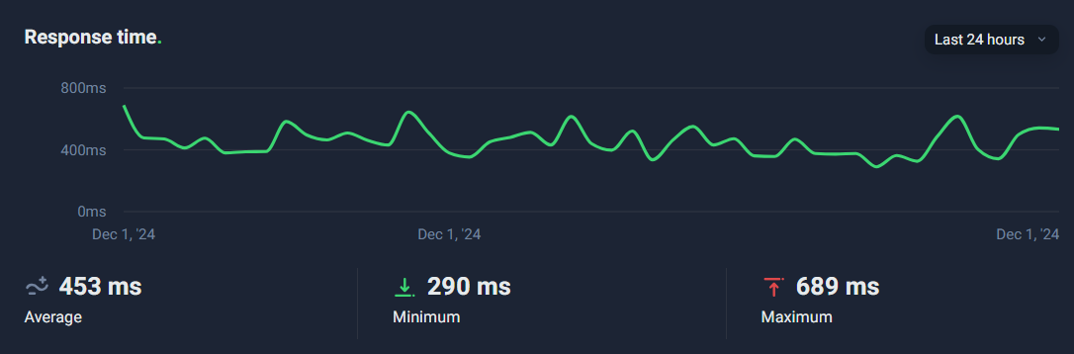

HTTP Request v/s Time

* No major drops of response time throughout 24 hours.
* Multiple user activity shows drop in response time, but not major.
* Users: 9-10, working parallel